FOREX STOCK TREND PREDICTION FOR FOREX MARKETS USING MACHINE LEARNING APPROACH

ERICK MURU GITHINJI
SCT221-0972/2021

A Project Proposal submitted to the Department of Information Technology in the School of Computing and Information Technology in partial fulfillment of the requirement for the award of
Degree in Information Technology at Jomo Kenyatta University of Agriculture and Technology.
January, 2026

DECLARATION
I hereby declare that this project is original and has not been published or submitted for any other diploma or degree award to any other university before.

Student Name: ERICK MURU GITHINJI

Signature…………………..Date……………

This project has been submitted for examination with the approval by the Supervisor.

Supervisor Name: DR KABURU

Signature………………. Date………………

ACKNOWLEDGEMENT
First and foremost, I would like to express my gratitude to Almighty God for giving me a graceful bearing till this time of my life. Secondly, I thank my family for support in the process of carrying out my project. I am also grateful to my project supervisor, DR KABURU for guiding and helping me to carry out my project and acquire several skills that will help me in the project areas of related tasks.

Contents
DECLARATION ii
ACKNOWLEDGEMENT iii
TABLE OF FIGURES vi
LIST OF ACCRONYMS vi
ABSTRACT vii
CHAPTER ONE 6
1.0 INTRODUCTION 6
1.1 Background of study 6
1.2 PROBLEM STATEMENT 7
1.3 PROPOSED SOLUTION 8
1.4 OBJECTIVES 8
1.5 Research questions 8
1.6 JUSTIFICATION 9
1.8 SCOPE OF THE STUDY 10
CHAPTER 2 10
2.0 LITERATURE REVIEW 10
2.1 Introduction 10
2.2 Existing prediction algorithms 11
2.3 Challenges and Limitations: 15
2.4 Conclusion: 16
CHAPTER 3 17
3.0 PROPOSED RESEARCH AND SYSTEM METHODOLOGIES 17
3.1 Agile methodology 17
3.2 Data Collection Methods 18
CHAPTER 3 19
3.0 SYSTEM ANALYSIS AND DESIGN 19
Introduction 19
3.1 Feasibility Study 19
3.2 Requirement Elicitation 21
3.3 Data Analysis 23
3.4. SYSTEM SPECIFICATIONS 25
3.4.1 Functional Requirements 25
3.4.2 Non-Functional Requirements: 26
3.5 Requirements Analysis and Modelling 26
3.6 System design 30
3.6.1 Logical design 30
3.6.2 System architecture 31
3.6.3. Physical design 32
User Interface Designs. 32
System mockups. 34
SYSTEM IMPLEMENTATION AND TESTING, CONCLUSIONS AND RECOMMENDATIONS 36
4.0. Introduction 36
4.1 Environment and Tools 36
4.1.1 System Code Generation 36
4.1.2 Snapshots of the system 39
4.2 TESTING 40
Testing Plan 40
4.2.1 Unit Testing 40
4.2.2. GUI Testing 41
4.2.3. Integration Testing 42
4.2.4. Acceptance Testing 43
4.2.5. Testing predictions 43
Conclusions 44
REFERENCES 45
APPENDIX: 47
PROJECT SCHEDULE 47
GANTT CHART 48
BUDGET 48
APPENDIX 48
Questionnaire 48
Interview questions 51
RESOURCES REQUIREMENTS 51

TABLE OF FIGURES
Figure 1 Activity diagram 27
Figure 2 Use case Diagram 28
Figure 3 Sequence diagram 29
Figure 4 logical Design 30
Figure 5 System Architecture 31
Figure 6 User interface home page 32
Figure 7 Prediction page 33
Figure 8 system mockup 34
Figure 9 predicted trend 35
Figure 10 Calculated moving averages form 35
Figure 11 Stock data fetching 38
Figure 12 Fetching stock news and fundamental data 38
Figure 13 Model training 39
Figure 14 Successful epoch's 39
Figure 15 system snapshot home page 40
Figure 16 snapshot for stock predictor 41

LIST OF ACCRONYMS
AI Artificial intelligence
ANN Artificial Neural Networks
ARIMA Autoregressive Integrated Moving Average
DNN Deep neural networks
EMA Exponential Moving Average
GARCH Generalized Autoregressive Conditional Heteroskedasticity
LSTM Long Short- Term Memory
MA Moving Average
NLP Natural language Processing
RNN Recurrent neural networks
SMA Simple moving average
SVR Support vector regression

ABSTRACT
Finances represent one of the key requirements to perform any useful activity for humanity. Financial markets, e.g., stock markets, forex provide the opportunity to anyone to invest and generate finances. However, to reap maximum benefits from these financial markets, effective decision making is required to identify the trade directions, e.g., going long/short by analyzing all the influential factors, e.g., price action, economic policies, and supply/demand estimation, in a timely manner. In the dynamic realm of financial investments, it is often challenging for investors to accurately predict stock market fluctuations, leading to potential financial losses. Developing a web-based application project to facilitate accurate prediction and analysis of stock market trends through the implementation of machine learning algorithm., Stock prediction aims to provide investors with timely, reliable, and data-driven insights into the performance of various stocks, allowing them to make informed investment decisions. By leveraging advanced machine learning and data analysis techniques, Stock prediction offers users real-time access to comprehensive stock market data, trend predictions, and actionable insights. This platform effectively minimizes the need for extensive manual analysis and costly consultations with financial advisors, empowering users to make informed investment choices independently. With its user-friendly interface and customizable features, Stock predictor caters to both novice and experienced investors, equipping them with the tools needed to navigate the complexities of the stock market.

CHAPTER ONE

1.0 INTRODUCTION

1.1 Background of study
The stock market plays a vital role in the global economy, impacting individual investors, corporations, and governments. Predicting stock prices accurately is a challenging task, and achieving this goal has significant financial implications. With the rise of computational power and data availability, machine learning has emerged as a powerful tool for stock price prediction. There are two types of stock analysis that investors undertake before investing in a stock. The first is fundamental analysis, in which investors look at the fundamental value of companies as well as the performance of the industry, economy, political climate, and so on to determine whether to invest or not. However, despite the being successful in analysis this type of analysis is faced with a lot of limitations. Fundamental analysis does not always reflect short-term movements in the stock market charts also it depends on the accuracy of financial statements and forecasts. Technical analysis, on the other hand, is the examination of market activity statistics such as past prices and volumes to determine the evolution of stocks. it is based on historical price and volume data, which is readily available it also provides visual patterns and signals for traders. Despite providing visual patterns technical analysis prediction it is faced with a number of challenges. Since it Relies on historical data and may not capture fundamental factors. Another big challenge facing technical analysis tools is they are Subject to interpretation, and different analysts may reach different conclusions. In the recent years, increasing prominence of machine learning in various industries has enlightened many traders to apply machine learning techniques to the field, and some of them have produced quite promising results. This project will develop a stock prediction tool which will be based on machine learning models. The Long Short-Term Memory (LSTM) networks are a type of recurrent neural network (RNN) capable of addressing linear problems. LSTM model will have a dataset storing all historical stock prices and data will be treated as training sets for the program. This model will also include moving averages. Moving average in finance is a stock indicator commonly used in analysis of market trends. Moving averages are calculated to identify the trend direction of a stock or to determine its support and resistance levels. They also provide a smooth trend identification which is easy to interpreted and understand. By calculating the moving average, the impacts of random, short-term fluctuations on the price of a stock over a specified time frame are mitigated. The main purpose of the prediction is to reduce uncertainty associated to investment decision making. Stock Market follows the random walk, which implies that the best prediction you can have about tomorrow’s value is today’s value. Indisputably, the forecasting stock indices are very difficult because of the market volatility that needs accurate forecast model. The financial exchange records are profoundly fluctuating and it impacts the financial backer's conviction. Stock prices are considered to be a very dynamic and susceptible to quick changes because of underlying nature of the financial domain and in part because of the mix of a known parameters (Previous day’s closing price, P/E ratio etc.) and the unknown factors (like Election Results, Rumors etc.). There have been various endeavors to anticipate stock cost with AI. The focal point of each exploration projects shifts a great deal in three ways.
- The targeting price change can be near-term (less than a minute), short-term (tomorrow to a few days later), and a long-term (months later).
- The set of stocks can be in limited to less than 10 particular stocks, to stocks in particular industry, to generally all stocks.
- The predictors used can range from a global news and economy trend, to particular characteristics of the company, to purely time series data of the stock price.
In order to come up with an efficient forex prediction tool this project will apply moving averages as the main strategy in analysis of the market. A moving average (MA) is a stock algorithm commonly used in technical analysis. The reason for calculating the moving average of a stock is to help smooth out the price data by creating a constantly updated average price.

1.2 PROBLEM STATEMENT

In the dynamic and profoundly unpredictable forex market, analyzing and predicting the forex (foreign exchange) market is a complex task due to factors such as market volatility, market hours and data quality. The biggest challenge in forex market analysis and prediction of stocks is market volatility (Goddard, J., Kita, A., & Wang, Q. (2015)), which is characterized by frequent and rapid price fluctuations. Predicting price movements in such a dynamic environment can be challenging making it hard to take trades and may lead to huge losses. Use of analysis tools such as fundamental analysis tools do not always reflect short-term movements in the stock market charts. This is a great challenge when it comes to predicting the next market move. Different interpretation when using technical analysis tools such as chart patterns is another challenge since different people have difference interpretation abilities. There has been a rapid progression in the use algorithms in forex trading in prediction for loss prevention. Using techniques such as technical analysis tools for example moving average algorithm can be of great assistance to making profits

1.3 PROPOSED SOLUTION
In order to curb the challenge of market analysis and market volatility, short term price movements and trend interpretation the need for a comprehensive forex stock prediction solution that is user-friendly. Application of Machine learning algorithms will help to solve the volatility and inconsistent interpretation issues. The Long Short-Term Memory (LSTM) are designed to work with sequential data, making them a natural choice for stock prediction tasks Since the neural networks apply simple moving average technique, they can avoid noises and therefore smooth the trend movement. This solution can be adapted to the needs and available resources of both stock and forex markets. The proposed stock prediction algorithm for forex markets aims to address these challenges and offer investors or new users looking to start up on forex trading a prediction tool which is practical, efficient, and scalable.

1.4 OBJECTIVES
General Objective
To develop a stock prediction tool for forex markets.
Specific Objective
The application will precisely focus on the following objectives:
- To investigate the existing techniques for stock prediction.
- To design and develop a stock prediction prototype.
- To test the developed prototype in real world scenario.

1.5 Research questions
- What are the methods used for stock prediction?
- What are the methods used to develop a stock prediction prototype?
- What are the methods of testing that will be used?

1.6 JUSTIFICATION
stock prediction algorithms are used in trading and investing based on their ability to improve decision-making and risk management for traders and investors. Here are a few compelling arguments in favor of using stock prediction algorithms:

- Increasing Decision-Making: Stock prediction algorithms offer insightful data that can inform trading and investment choices. They provide insights into probable price changes in the future, assisting traders and investors in making more knowledgeable decisions.
- Risk management: Traders can spot possible risk factors and take action to mitigate them by employing algorithms. For instance, avoiding buying at the height of a rally or selling at the bottom of a slump can be avoided by traders using algorithms like the Relative Strength Index (RSI) to detect overbought or oversold conditions.
- Timing Trades: Algorithms can help traders time their entry and exit locations. By assisting traders in determining the best times to buy (long) or sell (short), they may be able to maximize gains and reduce losses.
- Confirmation and Validation: Algorithms can validate trading and investment hypotheses. When multiple algorithms align, they can provide stronger signals for traders to act upon, reducing the likelihood of false signals.
- Reducing Emotional Bias: Feelings like fear and greed might cause people to make snap judgments about their trade. A methodical and objective framework is provided by stock prediction algorithms, which lessens the impact of emotions on trading techniques.

1.7 CRISP-DM METHODOLOGY
The proposed methodology to be used is CRISP-DM (Cross-Industry Standard Process for Data Mining), as it provides a structured, iterative, and flexible framework for data-driven and analytical projects. CRISP-DM emphasizes continuous learning, stakeholder involvement, and adaptability throughout the project lifecycle, ensuring that solutions remain aligned with business objectives.
Rather than strictly following a linear process, CRISP-DM supports an iterative and incremental approach, allowing teams to revisit earlier phases as new insights emerge. Client and stakeholder feedback is incorporated at every stage, from understanding business needs to deploying and evaluating results. This methodology prioritizes flexibility, collaboration, and responsiveness to change, enabling teams to deliver meaningful and actionable insights effectively.

1.8 SCOPE OF THE STUDY
The scope of the study in the context of algorithmic trading is concentrated on individuals seeking to develop and implement algorithmic trading strategies for financial markets. The focus is on providing guidance and tools to help these individuals effectively trade in financial markets using algorithms. This algorithmic trading platform aims to assist users in making informed trading decisions, optimizing their trading strategies, and managing risk. The target users are traders and investors looking to adopt algorithmic trading practices to enhance their financial portfolio and trading outcomes.

CHAPTER 2

2.0 LITERATURE REVIEW

2.1 Introduction
Financial research has looked into how stock markets are impacted on some dimensions by data that comes from multiple sources and is diverse. The term "multi-source heterogeneous data" refers to data that is derived from a variety of sources, including the foreign exchange market, the stock market, the weather system, and the structure of trading volumes, stock prices, announcements, and social media. and other unstructured data. In particular, the efficient market hypothesis believes that information from various sources in the stock market will have an impact on the stock market, while behavioral finance believes that financial markets are explained, studied and predicted from the individual behaviors of traders and the motivations that produce such behaviors. the trend and extent of price fluctuations. These studies point out that the internal mechanism of the stock market is very complex, similar to Brownian motion. Combining the multi-source heterogeneous data in the stock market can more accurately classify and predict the stock market state. With the vigorous development 7 of the stock market, it continues to generate a large number of multi-source heterogeneous data of various scales. The traditional idea of relying solely on experts to analyze and predict has been difficult to meet the needs of industry development (Bhattacharjee, I., & Bhattacharja, P. 2019.). In order to quickly analyze massive stock market data and assist or even completely replace investors in making stock market investment decisions, a large number of researches on stock market forecasting based on information technology have emerged.
These studies have also contributed to the rapid development of quantitative funds that rely on automated computer analysis to execute and even make investment decisions entirely on their own (Chen, J., Jiang, F., & Tong, G. 2019). Obtaining accurate stock price forecasts can more effectively avoid future risks for decision makers; for regulators, it can strengthen the control of the stock market, regulate and guide the stock market in a timely manner, and contribute Toth sustainable development of the economy. Development provides firm confidence and strong guarantees. The so-called stock price forecast is to use various scientific methods to predict the development prospects of the stock market through the regularity of the development of the stock market and its history and status, relying on a large amount of stock market information and accurate statistical survey data (Javed Awan, M., Mohd Rahim, M. S., Nobanee, H., Munawar, A., Yasin, A., & Zain, A. M. (2021).). For decades, scholars have explored various forecasting methods. Therefore, reading about relevant research and summarizing and classifying these forecasting methods has certain positive significance for further research.

2.2 Existing prediction algorithms
Stock data is a classic time series, and many researchers have used time series models for forecasting, such as Autoregressive Integrated Moving Average (ARIMA) or Generalized Autoregressive Conditional Heteroskedasticity (GARCH) models, (Alfaki, M. M. A., & Masih, S. B. 2015.), but the assumptions of classic timeseries models are relatively high, such as the need for the series to be stationary and linear. However, the factors that affect the stock price of stock data come from many aspects, which makes the stock data itself not stable and linear. Although the difference method can be used to make the sequence stationary, the difference operation also causes data loss., which makes the traditional time series model have great limitations in forecasting. With the development of computer science and artificial intelligence, more and more researchers choose machine learning models for prediction, such as support vector machines, perceptron models, etc., because decadal with nonlinear data, especially support vector machines, the model has a nonlinear kernel function, so it has been used by the majority of people in the industry for a period of time. Predicting stock prices or other financial asset prices is very important to investors because investors usually reduce their decision-making risk by adjusting the allocation of investment assets. It is a very challenging problem to accurately predict when and how to allocate the asset budget at that time, because there are many factors that can affect the stock price, such as the company's asset allocation or operating conditions, and the impact of economic and political policies in related industries., the occurrence of emergencies and the exchange rate of currencies, etc. Therefore, many investors have used technical and quantitative methods to try to predict the volatility of asset prices. These methods include finding relatively suitable patterns from historical market data, as well as pinpointing the best time to make investment decisions. The question of whether the stock market is predictable has been debated for decades, and there is still no conclusion.
Progress of stock price prediction
the research on stock behavior was first conducted by Bachelier in 1900. Housed random walks to express stock price trends. Fama tested that stock price changes are characterized by random walks. Malkiel and Fama studied valid market assumptions in 1970 and found that all new information will be reflected in asset prices immediately without delay. Therefore, changes in future asset prices have nothing to do with past and present information. From their perspective, predicting future asset prices is considered impossible. On the other hand, many studies cryoprobe effective market hypotheses experimentally, and empirical evidence shows that the stock market can be predictable in some ways. In traditional time series models, parameter statistical models are used for forecasting, such as Autoregressive Integrated Moving Average (ARMA) model, ARIMA model and vector autoregressive model, etc., to find the best estimate. Virtanen and Yliolli used six explanatory variables to estimate the Finnish stock market index, including the lagging index and macroeconomic factors in an econometric model based on ARIMA. Work (Poongodi, M., Vijayakumar, V., & Chilamkurti, N. 2020.) proposed a stock price prediction system based on ARIMA in 2014, which has been tested in the listed stocks originated from the Stock Exchange in New York and the Stock Exchange running from the country Nigeria. Then the ARIMA model is regarded as a high potential model for forecasting short-term series. Although econometric models mentioned above can easily describe and evaluate the relationship between large number of variables through inference in the view of statistical, however these methods still have owned limitations for time series analysis in domain of finance. Firstly, they assume that the model structure is linear, anthocyanin capture the non-linear nature of stock prices. In addition, these models all assume that the data as a constant value, although the actual time series for finance are full of noise and have time-varying oscillation. Because of its ability in nonlinear mapping and induction, it has been widely used. Many experts try to model financial time nonlinear models, such as multi-layer neural networks and support vector machines with nonlinear kernel functions. They are differences from traditional economic models. Neural networks lack of a strict model structure and series of apparent assumptions. As long as there is enough data, it can be modeled. Work from proposed two mixed models to predict, combining Artificial Neural Networks (ANN) with exponential generalized ARIMA, and later predicted the volatility for S&P500 index return for the year 2012. Their calculation results show that the mixed model has lower test errors and its performance is better than the non-mixed single model. Kristjan poller et al. merged the generalized autoregressive conditional heteroscedasticity model (GARCH) and ANN and proposed a prediction model for the volatility in the Latin-American market, and showed that this model is superior to the Matchmade (its MSE is smaller). Work (Wang, Y., Liu, H., Guo, Q., Xie, S., & Zhang, X. 2019) from proposed a hybrid model of neural networks, random forest and support vector regression (SVR) i to predict the Indian stock market. Agarwal and Sastry combined the RNN neural network interwinds of linearization models with ARMA and exponential smoothing functionin2015, and predicted stock returns. The experimental results show that the predictability has been greatly improved, and the improvement is mainly contributed by the RNN neural network. For recent studies.
Long Short-Term Memory LSTM neural networks that are properly built to learn temporal module have been widely used in various tasks of time series analysis. The reason why LSTM is advanced than traditional RNN is that it solves the problem that RNN neural network fails to solve, that is, the problem of gradient explosion and gradient disappearance, and it can learn effectively through storage units and "gates", and is useful for information for long-term memory. Therefore, many experts have used LSTM to conduct a lot of research on financial time series modeling. In experiments, LSTM is superior to support vector machines due to the addition of emotional features, so that the accuracy of predicting the opening price of the next day has been significantly improved (from 78.57% to 87.86%). The work from Dai, Z. F., Dong, X. D., Kang, J., & Hong, L. (2020) used the textual data from the newspaper at Nikkei as the input of the LSTM neural network, and combined nighttime series data in stock market to predict the opening price of 10 selected companies. A trading strategy based on the predicted results is simulated. The experimental results show that the model has a higher profit value than the trained model only with stock data. When using deep neural networks (DNN) for financial time series analysis, researchers are more concerned about the problem of overfitting. Within a year, we can collect only about 252 data points per day. DNN has a good representation ability, because they learn the highly complex nonlinear relationship between variables, so the model has a high accuracy on the training set, but this makes the model prone to overfitting. In order to improve the generalization ability of the model, many researchers have conducted research on regularization methods such as L1 and L2 regularization, Dropout, early stopping, and reducing learning rate. These methods can avoid the problem of overfitting. For artificial neural networks, reducing the size of the neural network can also prevent overfitting, but since larger and deeper networks can solve more complex problems, there must be enough data to use deeper and larger networks. Therefore, the data enhancement method becomes a two-pronged method that can reduce the degree of over-fitting and improve the accuracy of generalization at the same time. However, this method is widely used in image processing problems. Unlike image data, data enhancement of financial time series is not a simple matter. Image data enhancement can be achieved through a variety of transformation techniques. For example, transformation-based data expansion methods will distort the original data to generate new composites. Therefore, although data enhancement of financial time series is of great significance in improving the performance and robustness of deep learning models, it has limited academic attention. If the dimensionality of the input data is reduced and used as input in a neural network, information loss may occur. An important advantage of deep learning is that it can learn features from the input data itself.
However, for recurrent neural networks, as the number of network layers continues to increase, the earlier the input data, its influence on the output results will be more and more weakened due to the increase in sequence length, which leads to the RNN neural network Long-term memory of information is weak. Hochreiter and Schmid Huber in their 2020 paper "Long Short- Term Memory", they proposed the LSTM neural network for the Nonneural network's inability to solve the long-order dependence of the time series. They introduced the "gate" in the LSTM neural network. concept. Felix et al. optimized the LSTM neural network in 2000. Considering that the memory storage unit of the neural network will increase with the increase of the sequence length, which may cause the network to collapse, they proposed to add a forgetting gate inside the LSTM neuron. At this point, the prototype of the LSTM neural network has been completed. The LSTM neural network can control the transmission of input data through input gates, forget gates and output gates, and maintain the independence of the output of the memory storage unit and the result output, so that the sequence can retain important information during transmission and maintain it for a longer period of time memory. Therefore, the application of LSTM neural network in the prediction of financial time series has become more and more extensive.
Stock Trend Prediction Using Simple Moving Average Supported by News Classification (Stefan Lauren Dra. Harlili S., M.Sc. 2019) The simple moving average is one of many times series analysis technique. Time series analysis is a method of timely structured data processing to find statistics or important characteristics for many reasons. The simple moving average shows stock trend by calculating the average value of stock prices on specific duration. The prices that are used are closing prices at the end of the day. This technique can avoid noises and therefore smooth the trend movement.
The main objective of financial news classification is to classify and calculate each news’ sentiment value. The positive news is marked by sentiment value which is greater than 0, while negative news is marked by less than 0 sentiment value. If there are news having 0 sentiment value, they will be omitted as their neutralism does not affect the stock trend.
Machine learning using artificial neural network algorithm is used to predict a stock trend. The artificial neural network uses three features along with one label. The three features are a simple moving average distance which is a subtraction of long-term and short-term simple moving average, the total value of positive sentiment value for one-day news, and the total value of negative sentiment value for one-day news. Stock trend label is used and classified as uptrend and downtrend. Moving averages are calculated to identify the trend direction of a stock or to determine its support and resistance levels. It is a trend-following or lagging, indicator because it is based on past prices.
The longer the period for the moving average, the greater the lag. A 200-day moving average will have a much greater degree of lag than a 20-day MA because it contains prices for the past 200 days. 50-day and 200-day moving average figures are widely followed by investors and traders and are considered to be important trading signals. Investors may choose different periods of varying lengths to calculate moving averages based on their trading objectives. Shorter moving averages are typically used for short-term trading, while longer-term moving averages are more suited for long-term investors. These moving averages are calculated using given formulas as shown below.
Simple Moving Average. A simple moving average (SMA), is calculated by taking the arithmetic mean of a given set of values over a specified period. A set of numbers, or prices of stocks, are added together and then divided by the number of prices in the set. The formula for calculating the simple moving average of a security is as follows:
SMA=$\frac{A1​+A2​+…+An}{n}$
where:
A=Average in period n
n=Number of times periods​
Exponential Moving Average (EMA)
The exponential moving average gives more weight to recent prices in an attempt to make them more responsive to new information. To calculate an EMA, the simple moving average (SMA) over a particular period is calculated first. Then calculate the multiplier for weighting the EMA, known as the "smoothing factor," which typically follows the formula: [2/ (selected time period + 1)]. For a 20-day moving average, the multiplier would be [2/ (20+1)] = 0.0952. The smoothing factor is combined with the previous EMA to arrive at the current value. The EMA thus gives a higher weighting to recent prices, while the SMA assigns an equal weighting to all values.
$EMAt​ =\left[Vt​×{\left.\left( \frac{s}{1+d}\right.\right)}^{}\right]$+EMAy ​×$\left[1 - {\left.\left( \frac{s}{1+d}\right.\right)}^{}\right]$
where:
EMAt ​=EMA today
Vt​=Value today
EMAy​=EMA yesterday
s=Smoothing
d=Number of days​

2.3 Challenges and Limitations:
Despite significant progress, challenges persist in the field of stock market prediction:
- Data Quality: Inaccurate, incomplete, or unstructured data sources can limit the effectiveness of prediction algorithms.
- Model Interpretability: The 'black-box' nature of some AI models hinders the interpretability of results, which is a concern for stock market prediction.
- Generalization: Models may perform well in controlled research settings but struggle to generalize to diverse stocks and market conditions.
- The previous results indicate that the stock price is unpredictable when the traditional classifier is used.
- The existing system does not perform well when there is a change in the operating environment.
- It doesn’t focus on external events in the environment, like news events or social media.
- It exploits only one data source, thus highly biased.

2.4 Conclusion:
The development of a stock prediction algorithm represents a critical step toward improving market analysis, reducing prediction costs, and enhancing the overall quality of stock market analysis. While traditional methods have been foundational, computational approaches, including machine learning and AI, are reshaping the landscape of stock market prediction. The challenges of data quality and model interpretability remain, but real-world implementations in stock market demonstrate the practical value of these applications. Collaboration among interdisciplinary teams, standardization of evaluation metrics, and continuous efforts to enhance model interpretability and algorithm integration are key to realizing the full potential of this field.

CHAPTER 3

PROPOSED RESEARCH AND SYSTEM METHODOLOGIES

CRISP-DM METHODOLOGY
The proposed methodology to be used is CRISP-DM (Cross-Industry Standard Process for Data Mining), as it provides a structured, iterative, and flexible framework for data-driven and analytical projects. CRISP-DM emphasizes continuous learning, stakeholder involvement, and adaptability throughout the project lifecycle, ensuring that solutions remain aligned with business objectives.
Rather than strictly following a linear process, CRISP-DM supports an iterative and incremental approach, allowing teams to revisit earlier phases as new insights emerge. Client and stakeholder feedback is incorporated at every stage, from understanding business needs to deploying and evaluating results. This methodology prioritizes flexibility, collaboration, and responsiveness to change, enabling teams to deliver meaningful and actionable insights effectively.

Data Collection Methods
The data collection tools that will be used are:
- Reviewing existing systems
There is a number of prediction methods and applications that already exists. These applications and methods can provide useful information to facilitate improvement and coming up with a favorable prediction tool. Some applications also consume a lot of time as they require the user to have basic technology knowledge.
- Questionnaires
Online administered questionnaires formulated using type forms will be used quantitatively in this research project. A link to the form will be shared with prospective study subjects via Facebook and WhatsApp platforms in various family groups. Questionnaires will be used since they are lot cheaper to administer and the response rate is higher than other methods of collecting quantitative data

CHAPTER 3

3.0 SYSTEM ANALYSIS AND DESIGN

Introduction
This chapter covered system methodology, requirement elicitation which helped in data collection of user and system requirements, and feasibility study all this which clearly gave me the overall image of how the system should look and operate. System analysis projects are initiated for three reasons: problems, opportunities, and directives. It also covered functional and non-functional system requirements, system logical design using Unified Modelling Language (UML) diagrams, and system physical design, including database design and user interface design.

3.1 Feasibility Study
A feasibility study is a crucial step to assess the practicality and viability of the proposed project. It involves evaluating the economic, technical, and other critical aspects to determine whether the project can be successfully implemented.
- Economic Feasibility
The cost estimates for developing the system are within budget while the benefits include, improved product quality leading to increased profits and customer satisfaction, potential cost savings through automated quality assessment and enhanced competitiveness in the stock market.
In cost Analysis, the implementation cost for developing the system, acquiring necessary hardware, software, and training, was analyzed. The budget allocation was found to be within the defined financial resources of Continental forex bureau limited. About the return on Investment (ROI), a conservative estimate was calculated, factoring in potential increased efficiency and reduced losses due to better quality control.
Return on Investment (ROI):
Total Costs:
Initial Investment (Development + Deployment): 40,000 KES + 40,000 KES = 80,000 KES
Annual Maintenance Costs: 22,000 KES
Net Annual Benefit:
Additional Trading Profits: 45,000 KES
Maintenance Costs: 22,000 KES
Net Annual Benefit: 45,000 KES - 22,000 KES = 23,000 KES
ROI:
ROI = (Net Annual Benefit / Total Costs) * 100%
ROI = (23,000 KES / 80,000 KES) * 100% ≈ 28.75% The ROI calculations suggested a favorable return within a reasonable timeframe, making the project economically feasible.
- Technical feasibility
The technical infrastructure and technologies required for the stock prediction system were assessed. Assessing the availability of data sources needed for stock forecasting, such as historical stock prices, financial statements, economic indicators, news sentiment data, and alternative data sources. It also involved evaluating the viability of data collection, cleaning, and preprocessing methods. Considering the computational resources and infrastructure required to build and maintain the stock prediction system, including hardware, software, and data storage. It was determined that the necessary hardware and software could be readily obtained and integrated into the existing IT infrastructure of the organization. The system was also deemed scalable to handle a growing volume of stocks. Moreover, the system architecture allowed for future upgrades and integration with emerging technologies.
- Operational Feasibility
The integration of the stock prediction system with existing workflow processes was evaluated. This involved assessing the practicality of integrating the stock prediction system into existing workflows and decision-making processes of target users. Evaluating user acceptance and usability considerations, such as the user interface design, ease of interpretation of predictions, and integration with trading platforms or investment management systems. The study found that the system could be seamlessly integrated into other organizations programs, ensuring minimal disruption to other existing operational flow. The system was seen as a valuable tool to streamline the evaluation process and enhance decision-making.
- Legal and Ethical Feasibility
The system will comply with all legal and ethical standards regarding data privacy, intellectual property, and usage rights. The study ensured that the system and its operations complied with Investment and Financial Analysts Act related to data privacy, intellectual property, and usage of stock data. The project aims to contribute positively to society by potentially reducing the rate at which new stock investors lose their money due to lack of knowledge.
- Schedule Feasibility
A detailed project timeline was developed, taking into account the complexity of the development process and potential challenges. The study confirmed that the project could be completed within the stipulated timeframe.

3.2 Requirement Elicitation
The primary data collection tool for this project was interviews, questionnaires and reviewing of existing systems. Data collection also involved getting data from secondary sources of data like online repositories. The data chosen was specifically of the highly traded stocks. This was done to ensure that the data obtained from secondary sources matched the primary data collected from the client. More so, this ensured that the model was trained on the same type of data but from different sources. Data collection was administered by getting views from the client ad also online repositories which is yahoo finance which provided the stock data of the current stock market.
Yahoo finance
Yahoo Finance is a comprehensive financial news and data platform provided by Yahoo, a multinational technology company. It offers a wide range of financial information, including stock quotes, financial news, analysis, portfolio management tools, and market data. Users can access real-time stock quotes, historical price charts, financial statements, analyst ratings, and other investment-related information for thousands of publicly traded companies worldwide. The data set for training the module was acquired from this repository.

Stock data sample
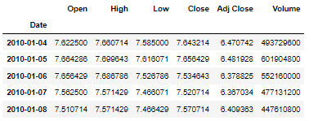

Stock company and stock symbols as used in stock market
COMPANY | SYMBOL
Google | GOOGL
Apple | AAPL
Amazon | AMZN
Microsoft | MSFT
Tesla | TSLA

We'll use this data to predict and forecast the worth of days into the future. Then we'll use the simplest Machine Learning Algorithm to predict the longer-term stock values in any company stock or other financial instrument traded on a financial exchange.

3.3 Data Analysis
The data was analyzed and interpreted using an Excel spreadsheet and the results displayed as illustrated below This section contains a continuation of the analysis of respondents concerning the non-functional requirements of the system as well as the interactivity of the software.
The total amount of stock data gathered for this dataset was 3522 files which are grouped into stocks opening price named open, stock closing price as close highest reading Ina day as high, lowest reading in a day as low and the volume of the stock as volume.

On a scale of 1-5, how important is it for you to have a reliable and trustworthy web-based stock prediction system? (1 - Not important at all, 5- Extremely important)
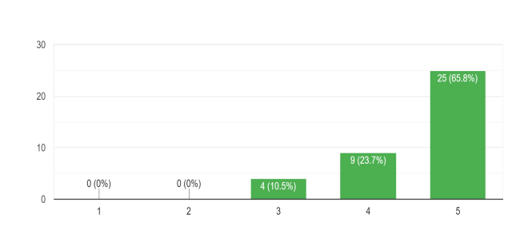
This analysis deduced that the respondents value an efficient channel that enables them to analyze and predict the stock trend easily.
How do you prefer to receive output of a stock trend?
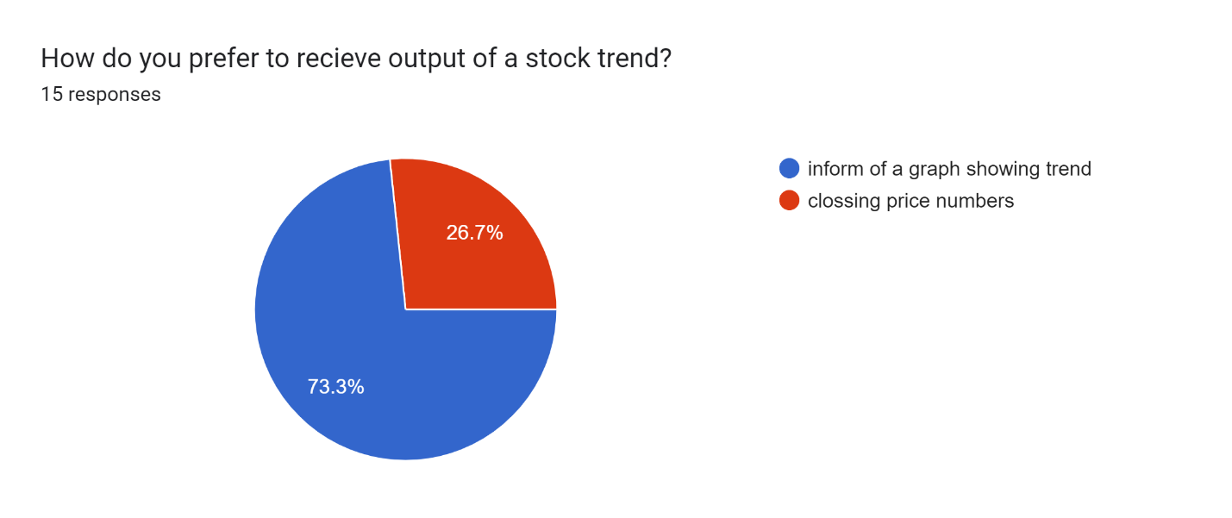
This analysis deduced that the respondents would a appreciate a system that will provide for them a stock trend in form of a graph.

How would you rate the succes rate o new stock investors inthe market acording to your yealy data

It was evident that new stock traders in the market are more likely to blow their accounts dues to lack of assistance and the difficulty in analyzing the stock trend.
How would you like a stock prediction system to provide output to you

The findings of this analysis deduced that the responders are truly faced by various challenges in their quest for stock prediction.

3.4. SYSTEM SPECIFICATIONS
System specification refers to a detailed description of the requirements, functionalities, and characteristics of a system. It outlined the specific features, behaviors, and constraints that the system should possess to meet the desired objectives and fulfill the needs of its users.

3.4.1 Functional Requirements
Functional requirements refer to what the system does. In this system they include;
- Accept user input
- Fetch historical stock data from yahoo finance
- Fetch stock news from alpha vantage stock news
- Preprocess the collected data by handling missing values and feature extraction
- Display top ten stock news
- Train machine learning models using the preprocessed historical data to predict future stock prices
- Generate predictions for future stock prices based on the trained models.
- Plot both stock data and predicted stock prices
- Plot weekly, daily and monthly stock trends
- Allow integration with external systems or APIs for accessing real-time data and incorporating it into the prediction models.

3.4.2 Non-Functional Requirements:
- Performance: The system should be able to handle large volumes of data efficiently and produce predictions within a reasonable timeframe.
- Accuracy: The prediction models should strive for high accuracy in forecasting stock prices to provide reliable insights to users.

- Scalability: The system should be scalable to accommodate increasing data volume and user demand without sacrificing performance.
- Reliability: Ensure high reliability by minimizing system downtime and errors, providing failover mechanisms, and implementing data backup strategies.
- Security: Implement robust security measures to protect sensitive financial data and user information from unauthorized access, breaches, or cyberattacks.
- Usability: Design the system with a user-friendly interface and intuitive navigation to facilitate ease of use for users with varying levels of technical expertise.
- Compatibility: Ensure compatibility with different platforms and devices to allow users to access the system from desktops, tablets, and smartphones.
- Maintainability: Design the system with clean, modular code and documentation to facilitate easy maintenance, updates, and troubleshooting by developers.
- Regulatory Compliance: Ensure compliance with relevant regulations and standards governing financial data handling and prediction systems.
- Ethical Considerations: Incorporate ethical considerations into the system's design and operation, such as transparency in model assumptions, avoiding bias in predictions, and respecting user privacy.

3.5 Requirements Analysis and Modelling
Requirement’s modeling is a technique used in software engineering and systems analysis create
visual representations or models that depict the various aspects of the system's requirements,
such as its functionality. This process of modeling involved using applications such as lucid char and plantuml web server.
Activity diagram
This activity diagram captures the main steps involved in the stock prediction process using an LSTM model and provides a clear flow of activities from user input to output.

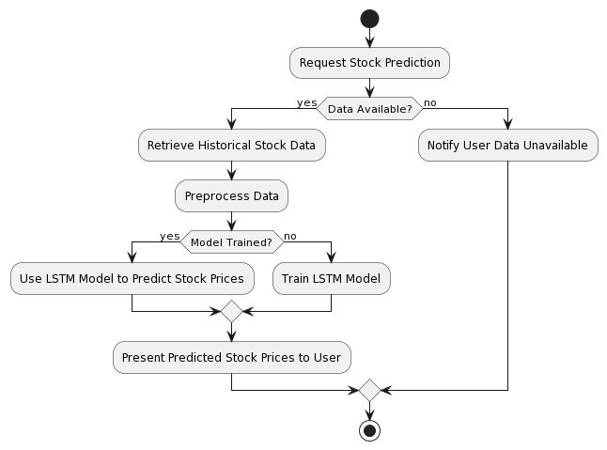
Figure 1 Activity diagram

- The user initiates the process by requesting a stock prediction.
- The system checks if historical stock data is available. If it is, the system proceeds with retrieving and preprocessing the data.
- If the LSTM model is already trained, the system directly uses it to predict stock prices. Otherwise, it trains the LSTM model first.
- Finally, the predicted stock prices are presented to the user. If no data is available, the user is notified accordingly.

Use Case Diagram
This diagram depicts the interactions between actors and the system, illustrating the system’s
functionality from the user’s perspective
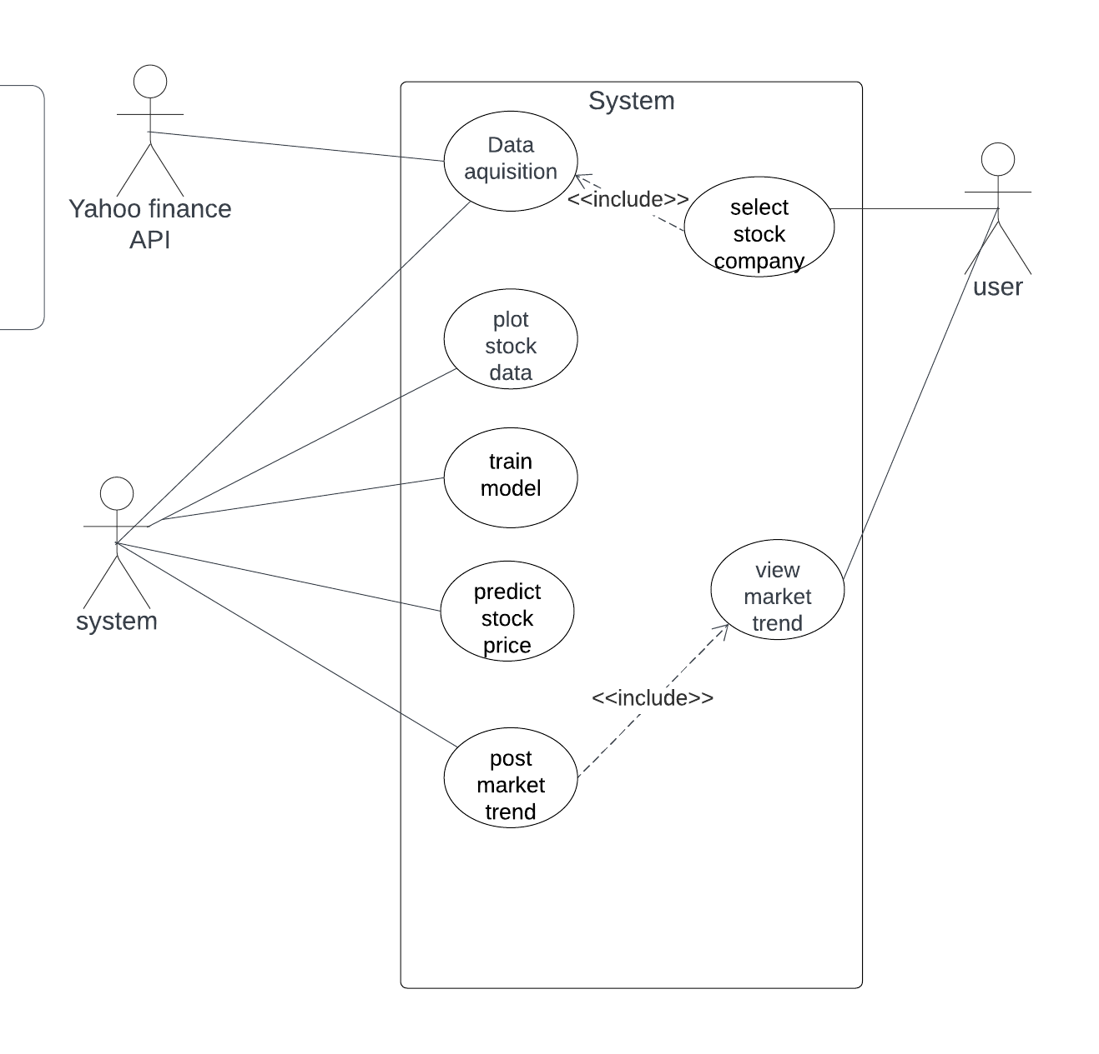
Figure 2 Use case Diagram

Sequence Diagram
These sequence diagrams show the flow of messages and interactions between objects or
components over time. They represent the dynamic behavior of a system by illustrating the
sequence of interactions between different entities. The diagrams representing objects or components, and horizontal arrows representing messages exchanged
between them. The sequence of messages is shown chronologically, allowing for a clear
understanding of the order of interactions.
Below are two sequence diagrams on illustrating the order of events for the stock investor.

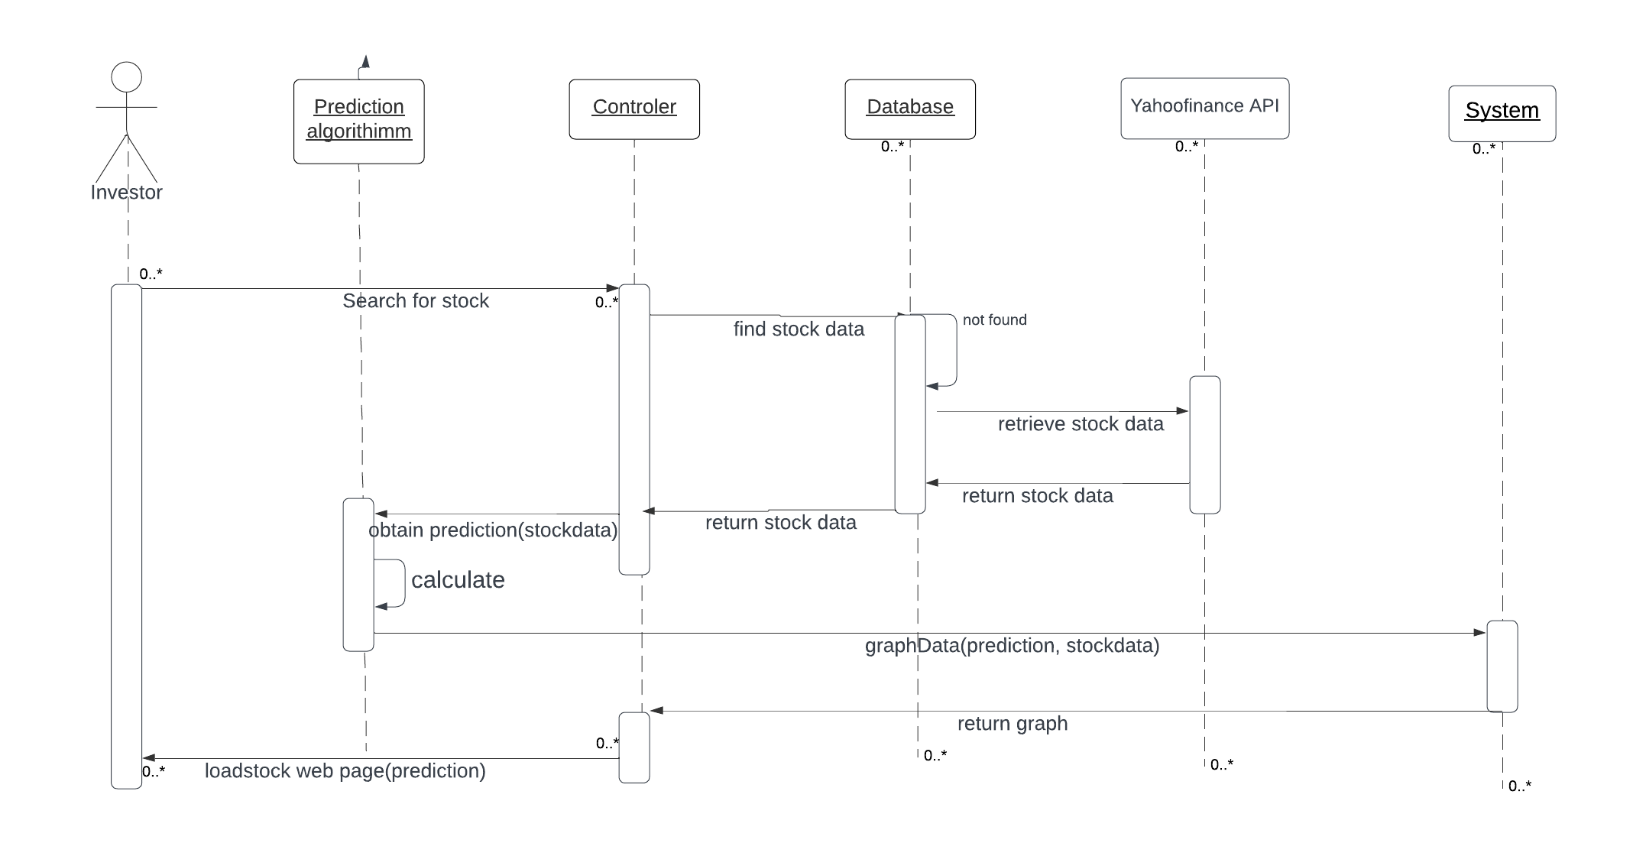
Figure 3 Sequence diagram

The sequence diagram shows that the system follows the following steps:
- The user enters the stock name.
- The application sends the stock name to the server application.
- The server application processes the stock ticker to extract relevant features.
- The server application uses the machine learning model to predict the stock trend.
- The server application sends the results back to the client application.
- The client application displays the results to the user.

3.6 System design
This section gives a complete overview of the system architecture shown in Figure 1 and the process flow diagram of the system gives in detail with a diagram and information

3.6.1 Logical design

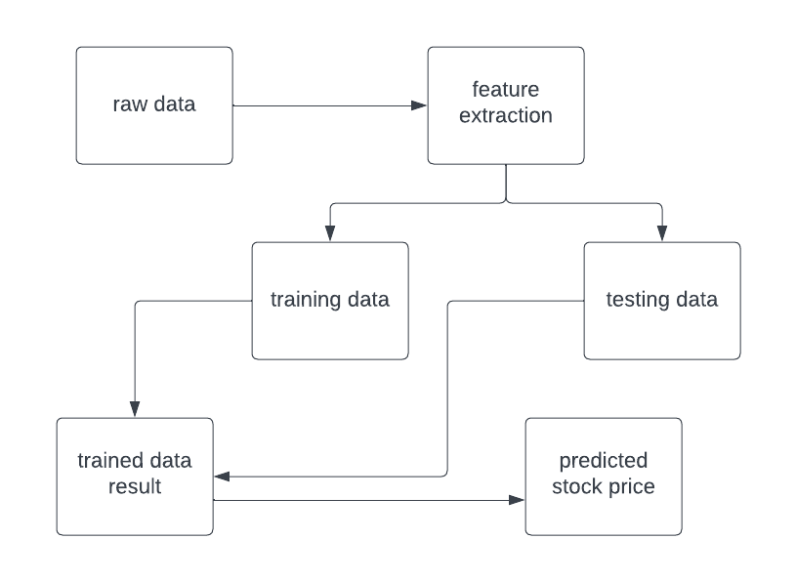
Figure 4 logical Design
Yahoo finance It is likewise have dataset for distinctive fields. Various statistics scientist competes to create the nice fashions for predicting. It permits the consumer to gather the dataset for the predicting process. To resolve the actual time statistics technological know-how challenge. The dataset used on this challenge has been downloaded from yfinance. The dataset accrued in uncooked format. Stock fee dataset of few agencies has been accrued. The first step is to gather the uncooked inventory charge facts and preprocess the facts

3.6.2 System architecture
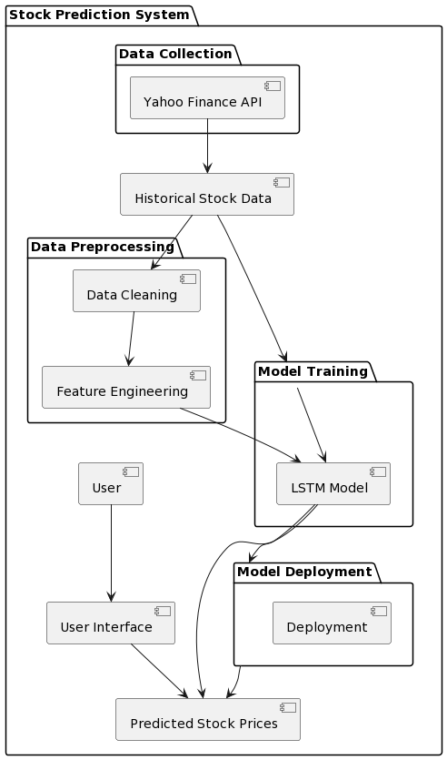
Figure 5 System Architecture
- Data Collection: The Yahoo Finance API collects historical stock data.
- Data Preprocessing: The collected data goes through cleaning and feature engineering processes.
- Model Training: The preprocessed data is used to train the LSTM model.
- Model Deployment: The trained model is deployed for prediction.
- User Interface: Users interact with the system to get predicted stock prices.
- Data Flow: Historical stock data flows through data preprocessing and model training to generate predicted stock prices, which are then presented to the user through the user interface.

3.6.3. Physical design

User Interface Designs.
The system will have a web application interface to allow for taking use input that will be sent to the machine learning model for prediction of trend. The interface will also display results to the user.
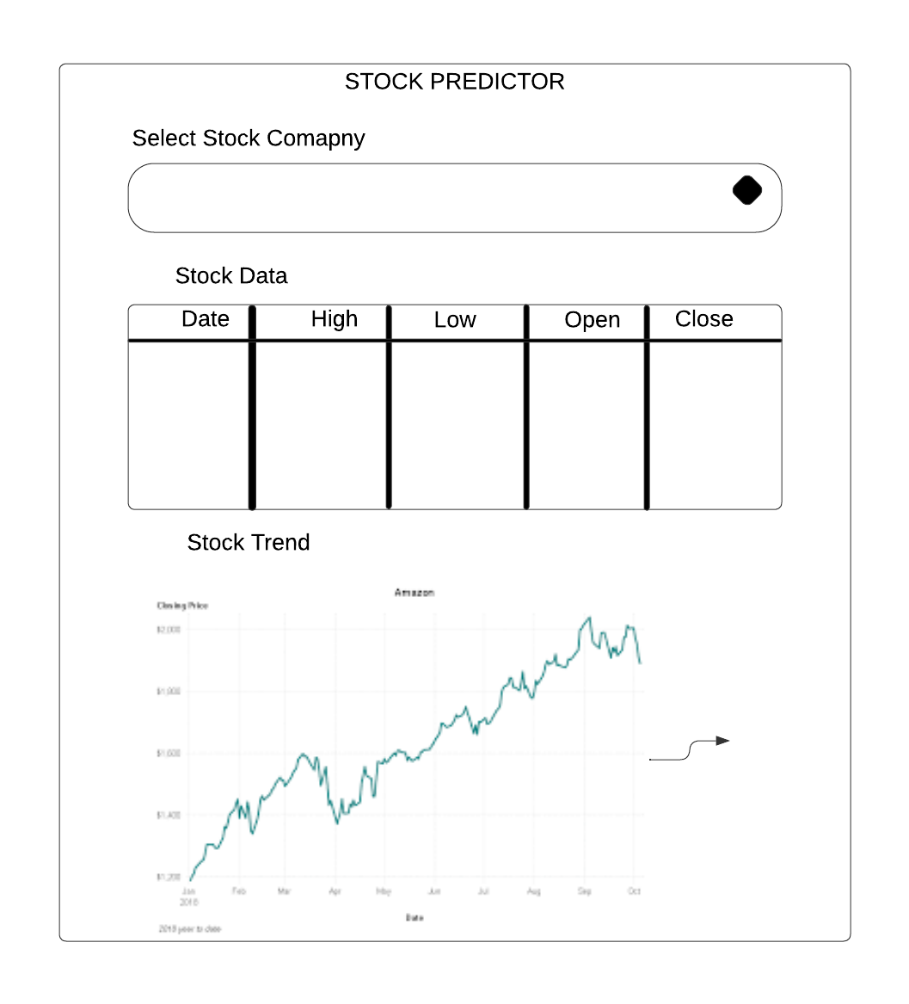
Figure 6 User interface home page
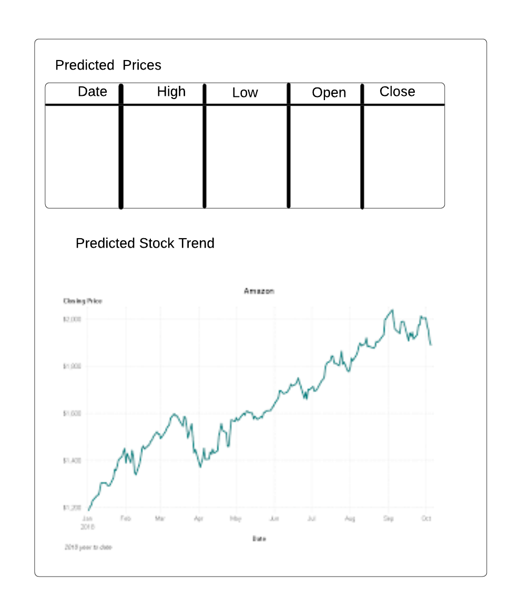
Figure 7 Prediction page

System mockups.
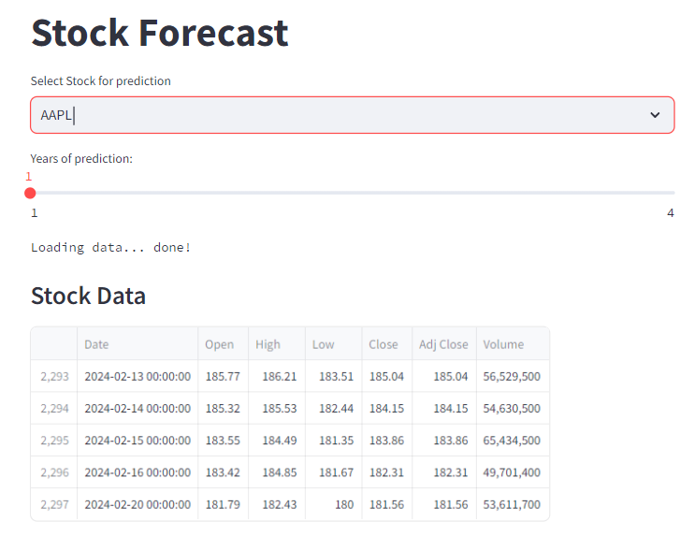
Figure 8 system mockup
when the user or investor accesses the system, this will be his/her landing page also the welcome page. In this page the user can select the stock name he or she would like to see the prediction.
After the user selects a stock to predict they will be provided with a forecast table of the predicted closing high and low stock prices.
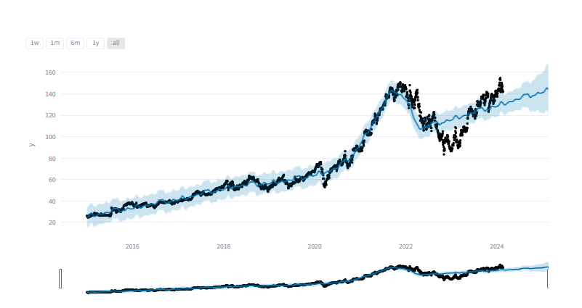
Figure 9 predicted trend
The system will also provide the user with a graph of the trend. This will be plotted where prediction against the actual stock price.
The system will also provide a 100 and 200 days moving average indicator for the user so as to assist in checking the accuracy of the predicted trend as shown below.
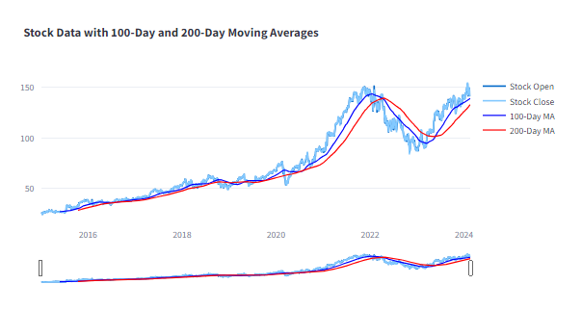
Figure 10 Calculated moving averages form

CHAPTER 4

SYSTEM IMPLEMENTATION AND TESTING, CONCLUSIONS AND RECOMMENDATIONS

Introduction
In this chapter, we delve into the implementation and testing phases of the mental health web application. This includes a detailed overview of the implementation environment, tools used, the process of code generation, testing strategies, and the outcomes. The chapter concludes with a reflection on the project's accomplishments, limitations, and recommendations for future enhancements.

4.1 Environment and Tools
The programming languages utilized in the implementation of the system are;
I utilized Streamlit, a Python library that simplifies the creation of web applications for machine learning and data science projects. Streamlit enables the creation of interactive web applications with minimal code, making it easy to showcase machine learning models and visualizations. I used Jupiter note book for data modeling and training of the model. for the user interface I used python programing language.
For the backend, I utilized Python along with frameworks like TensorFlow and Keras for implementing the LSTM model for stock prediction.
TensorFlow and Keras: These libraries provide powerful tools for building and training deep learning models, including LSTM networks for time series forecasting tasks like stock prediction.
Data Integration: I utilized the yfinance library to fetch historical stock price data directly from Yahoo Finance, allowing the model to train on real-world financial data.
Data Transmission: In this setup, data is processed and predictions are made within Jupyter Notebook using Python. The predictions or relevant data are then served to the Streamlit web application through JSON format for display to the end-user.

4.1.1 System Code Generation
The system was written and developed using python. The model was integrated into the web application using streamlit. The following are the snapshots of the system.
Fetching stock data from yahoo finance platform.
In order to perform predictions the system will download stock data from yahoo finance this will include opening, closing ,low, high and the adjacent closing prices of that stock selected. Importing the stock data directly from yahoo finance saves on time and space rather than having a database to store the data.
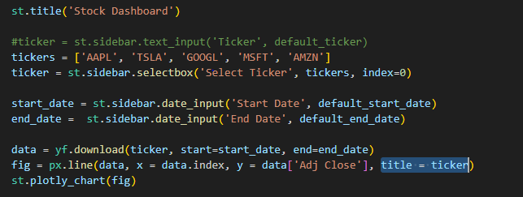
Figure 11 Stock data fetching
Connecting to alpha vantage
Connecting to alpha vantage grants access to stock fundamental data such as income statements and stock news that may affect the price movement of the stock. Having alpha vantage helps the model train the model with a complete data set therefore predicting stocks with a news sentiment. This connection is shown below.
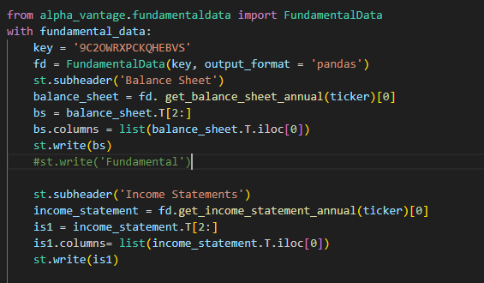
Figure 12 Fetching stock news and fundamental data

Model training
The training data is divided into batches. The neural network processes each batch of data and makes predictions. A loss function is used to calculate the difference (error) between predicted and actual outputs. Using the calculated gradients, optimization algorithms such as Gradient Descent are used to update the model parameters (weights and biases).
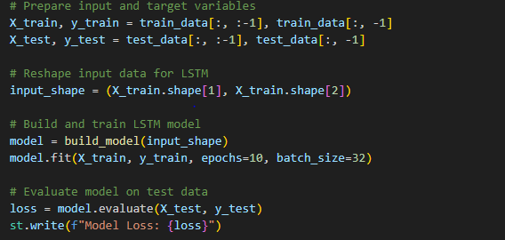
Figure 13 Model training
One complete pass through the entire dataset (all batches) is called an epoch. After completing an epoch, the model has seen and learned from the entire training dataset once.
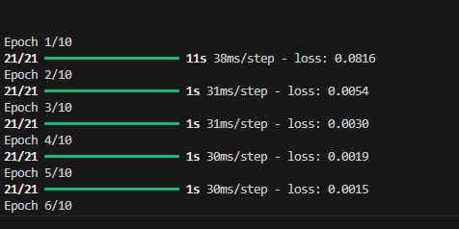
Figure 14 Successful epoch's

4.1.2 Snapshots of the system
Landing page
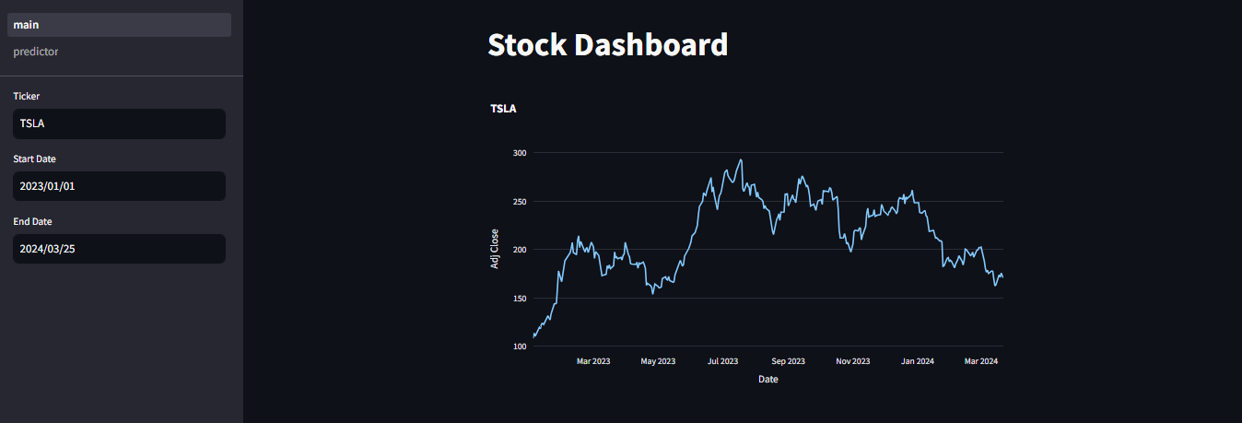
Figure 15 system snapshot home page
Stock data
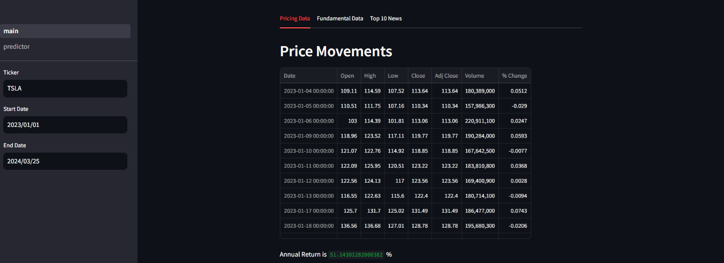

Stock predictions page
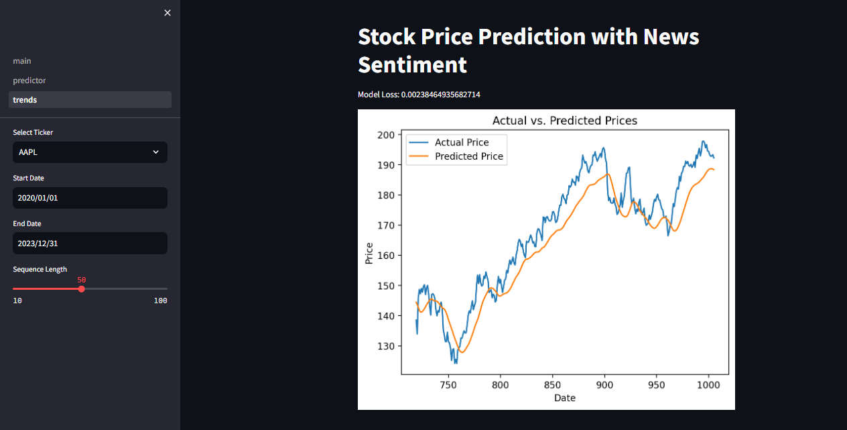
Figure 16 snapshot for stock predictor

4.2 TESTING
This section brings into light the overall testing strategy used for testing the web-based Application. Testing involved subjecting the system to a valid set of inputs to validate the set of outputs against the predetermined set of outputs.

Testing Plan
The testing plan involved doing individual module tests, to validate and verify that the system meets the requirements as guided by the developmental design.
The tests performed included the following; Unit Testing, GUI testing, Validation Testing

4.2.1 Unit Testing
This is a type of white box testing and it focuses on testing individual units or modules of software in isolation. It is a test in which the smallest testable portion of the software is tested to verify its functionality against its specification
Task To be Tested | Data fetching Process
Test Case | Verify the ability to fetch historical stock data and preprocess it for model training
Test Plan | - Fetch historical stock data using yfinance.  - Preprocess the data by handling missing values and scaling.
Expected Results | The system should successfully fetch historical stock data and preprocess it for model training.
Actual Results | Historical stock data was fetched and preprocessed without errors.

4.2.2. GUI Testing
GUI (Graphical User Interface) testing involves verifying the functionality, usability, and overall user experience of the application's graphical elements.
Task To be Tested | Testing the user interface for usability and functionality.
Test Case | Ensure the user interface provides an intuitive experience
Test Plan | - Interact with the user interface for fetching predictions.  - Verify the responsiveness and clarity of displayed information.
Expected Results | The user interface should be intuitive, responsive, and display predictions clearly.
Actual Results | The user interface provided a seamless experience with clear and responsive prediction displays.

4.2.3. Integration Testing
Integration testing involves assessing the seamless interaction and cooperation between various elements within the system. This testing phase is crucial to ensure that the individual components, previously developed and tested in isolation, harmonize effectively when integrated into the broader application.
In this testing approach, the primary focus is on evaluating the interplay of components, as opposed to isolated component testing. This emphasis is necessary because defects and issues often emerge at the points where different components converge, which may not become apparent during individual testing
- Unified Inter-Testing Approach: This method involved the integration of all components into a single testing scenario. Here a user interacted with all modules of the system. The goal was to assess the collective behavior of components when combined and identify potential conflicts or inconsistencies in their interactions.
- Error Handling and Exception Testing: It emphasizes scenarios where users provide ambiguous or erroneous inputs. Testing demonstrated the application's capability to gracefully handle errors and provide informative responses.

4.2.4. Acceptance Testing
Acceptance testing is performed to validate the software against the user requirements and is done in the final phase of testing. This testing ensure that the software does what the user wants it to do and checks the acceptability of the system
Test id | Description | Test done or not | result
1 | Does the system perform all the functions it is supposed to, as outlined in the requirements? | Yes | Not all
2 | Is the user documentation clear, comprehensive, and easy to follow? | Yes | Ok
3 | Is it easy to navigate throughout the system? | Yes | Ok
4 | Are all data inputs accurately processed and errors displayed where necessary? | Yes | Ok
5 | Can users access only the functions and data they are authorized to use? | Yes | Ok
6 | Does the system respond appropriately based on your input | Yes | Ok
7 | Are you satisfied with the rate at which the system responds? | Yes | Ok

4.2.5. Testing predictions
Visual Comparison. this involved Plotting the predicted trends generated by your model alongside the actual trends observed in the market. Use line charts to visualize both the predicted and actual stock prices over time. Visual inspection can provide immediate insights into how well the model's predictions align with reality.
Back testing: This involved conducting a back test to assess the profitability of trading strategies based on the model's predictions. Simulate trades using the predicted trends and evaluate their performance against the actual market outcomes. Back testing helps determine the practical utility of the model's predictions in real-world trading scenarios.

Conclusions
This section serves to summarize key findings, highlight achievements, and offer insights gained throughout the project. The following are achievements made in this project:
Enhanced interactivity: the implemented system has achieved key principles of interactivity such as feedback, consistency, visibility, and learnability. These interactive features have empowered users to access detailed product information and make informed decisions.
The user-centric approach, intuitive design, and responsive interfaces have amplified user engagement, enhancing the overall experience.
Recommendations
Scalability enhancements: Investigate ways to improve the prediction system's scalability so that it can handle more data and user requests. This could include optimizing data processing pipelines, leveraging distributed computing frameworks, or scalability through the use of cloud resources.
- Consider implementing off-chain scaling solutions, such as parallel or asynchronous data processing, to boost system throughput and response time.
- Consider alternative architectures, such as microservices or serverless computing, to improve scalability and meet the growing demand for stock prediction services.
Interoperability Standards:
- Develop interoperability standards and protocols to enable seamless integration with existing financial data sources, trading platforms, and analysis tools.
- Work with industry stakeholders, such as stock exchanges, financial institutions, and regulatory bodies, to create common data formats and APIs for interoperable data sharing.

REFERENCES
Goddard, J., Kita, A., & Wang, Q. (2015). Investor attention and FX market volatility. Journal of International Financial Markets, Institutions and Money, 38, 79-96.
Reznik, N., & Pankratova, L. (2018). High-Frequency Trade as a Component of Algorithmic Trading: Market Consequences. In ICTERI Workshops (pp. 73-83).
Cohen, G. (2022). Algorithmic trading and financial forecasting using advanced artificial intelligence methodologies. Mathematics, 10(18), 3302.
Yang, G. R., & Wang, X. J. (2020). Artificial neural networks for neuroscientists: a primer. Neuron, 107(6), 1048-1070.
Jorgenson, D. W., Weitzman, M. L., ZXhang, Y. X., Haxo, Y. M., & Mat, Y. X. (2023). Can Neural Networks Predict Stock Market?. AC Investment Research Journal, 220(44).
Kouaissah, N., Orlandini, D., Ortobelli, S., & Tichý, T. (2020). Theoretical and practical motivations for the use of the moving average rule in the stock market. IMA Journal of Management Mathematics, 31(1), 117-138.
Mahesh, B. (2020). Machine learning algorithms-a review. International Journal of Science and Research (IJSR).[Internet], 9(1), 381-386.
Obthong, M., Tantisantiwong, N., Jeamwatthanachai, W., & Wills, G. (2020). A survey on machine learning for stock price prediction: Algorithms and techniques.
Zhang, D., & Lou, S. (2021). The application research of neural network and BP algorithm in stock price pattern classification and prediction. Future Generation Computer Systems, 115, 872-879.
Javed Awan, M., Mohd Rahim, M. S., Nobanee, H., Munawar, A., Yasin, A., & Zain, A. M. (2021). Social media and stock market prediction: a big data approach. MJ Awan, M. Shafry, H. Nobanee, A. Munawar, A. Yasin et al.," Social media and stock market prediction: a big data approach," Computers, Materials & Continua, 67(2), 2569-2583.
Poongodi, M., Vijayakumar, V., & Chilamkurti, N. (2020). Bitcoin price prediction using ARIMA model. International Journal of Internet Technology and Secured Transactions, 10(4), 396-406.
Wang, Y., Liu, H., Guo, Q., Xie, S., & Zhang, X. (2019). Stock volatility prediction by hybrid neural network. IEEE Access, 7, 154524-154534.

APPENDIX:

PROJECT SCHEDULE

PROJECT SCHEDULE
ACTIVITIES | PROPOSED START DATE | ACTUAL START DATE | PROPOSED END DATE | ACTUAL END DATE | DELIVERABLES
Problem Identification | 03 Dec | 03 Dec | 15 Dec | 15 Dec | Project Idea
Proposal Writing | 16 Dec | 16 Dec | 25 Jan | 25 Jan | Problem Statement
Data Collection | 26 Jan | 26 Jan | 05 Feb | 05 Feb | Data Report
Data Analysis | 26 Jan | 26 Jan | 05 Feb | 05 Feb | Data Report
Design | 06 Feb | 06 Feb | 05 Apr | 05 May | System Design
Coding and Testing | 06 Apr | 06 Apr | 12 Apr | 10 May | Testing Result
Documentation | 13 Apr | 13 Apr | 20 Apr | 15 May | Project Documentation

Table 1 Project schedule

GANTT CHART
ACTIVITY | DECEMBER | JANUARY | FEBRUARY | MARCH | APRIL | MAY
SOFTWARE
REQUIREMENT
LOGICAL
DESIGN
DOCUMENTATION
PRESENTATION

Table 2 Gant chart

BUDGET
Item | Description | Estimated Cost (KES)
Laptop | Personal laptop for development(existing) | 0
Alpha-vantage | Alpha Vantage is one of the best data sources for both historical prices and fundamental data. | 1300
Internet Access | Data bundles/ Wi-fi | 5000
Software Tools | Visual studio code | 0
Documentation and printing, presentation materials | Slides preparation, flash disk, proposal printing, final report binding | 2000
Table 3 Budget

APPENDIX
Questionnaire
Stock prediction using machine learning approach
Erick Muru Githinji
Dear Respondent,
I am an Undergraduate student at Jomo Kenyatta University of Agriculture and Technology undertaking a Bachelor's Degree in Information Technology. I am currently conducting a study on Stock prediction using machine learning approach system. This Questionnaire is aimed at collecting information on system and user requirements. Your response will be treated with confidentiality and used for academic purposes only

- How would you describe your level of experience with stock markets and trading?

- No experience
- Beginner
- Experienced trader

- Have you used any other stock prediction systems before?

- Yes
- No

- In a scale how would you expect the user interface of the stock prediction system in terms of user-friendliness?

- 0
- 1
- 2
- 3
- 4
- 5

- How do you prefer to receive output of a stock trend?

- Inform of a graph showing trend
- Closing price numbers

- On a scale of 1-5, how important is it for you to have a reliable and trustworthy web-based stock prediction system? (1 - Not important at all, 5- Extremely important)
- 0
- 1
- 2
- 3
- 4
- 5

- What level of accuracy or prediction performance are you expecting from the system?
- 0
- 1
- 2
- 3
- 4
- 5
- 6
- 7
- 8
- 9
- 10

- Do you prefer the system to be fully automated, semi-automated, or used as a decision support tool alongside human judgment?
- Fully automated
- Semi-automated,
- Decision support tool alongside human judgment?

- On a scale of 1 -10 how important is data security and confidentiality for you?
- 1
- 2
- 3
- 4
- 5
- 6
- 7
- 8
- 9
- 10

Interview questions
Questions asked at continental forex bureau ltd
- What are your primary objectives in seeking a stock prediction system?
- Can you describe the specific challenges or pain points you're facing in your current approach to stock trading or investment decision-making?
- What are the key features or functionalities you expect from the stock prediction system?
- How do you envision integrating the stock prediction system into your existing workflow or investment strategy?
- Do you have any preferences or requirements regarding the presentation or visualization of stock prediction results?
- How would you rate the success of new stock investors according to your yearly data?
- What level of accuracy or reliability do you expect from the stock prediction system?

RESOURCES REQUIREMENTS
Hardware Requirements
- A Laptop or Desktop with the following specifications:
- Core i7 Processor (4 Cores Minimum)
- 16GB minimum RAM
- 1TB Hard-Drive (SSD recommended for faster processing)
- Windows/Linux/Mac Operating System

Software Requirements
The following software and tools will be required for development and deployment of the stock prediction system:
- Python 3.8+: Programming language used for implementing the system's logic and algorithms.
- Jupyter Notebook/Google Colab: For experimenting with LSTM model and conducting data analysis.
- Pandas, NumPy, Matplotlib, Seaborn: Python libraries for data manipulation, numerical computing, and data visualization.
- TensorFlow/Keras: Deep learning framework for building and training LSTM model for stock prediction.
- Streamlit: Python library for building interactive web applications. It will be used to create a user-friendly interface for users to interact with the prediction system.
- Yahoo Finance and Alpha Vantage APIs: For fetching historical stock data and real-time market data.
- News API: For retrieving latest news related to stocks and financial markets.

